Malvern Primary School

Online Safety Newsletter: Jan 2017

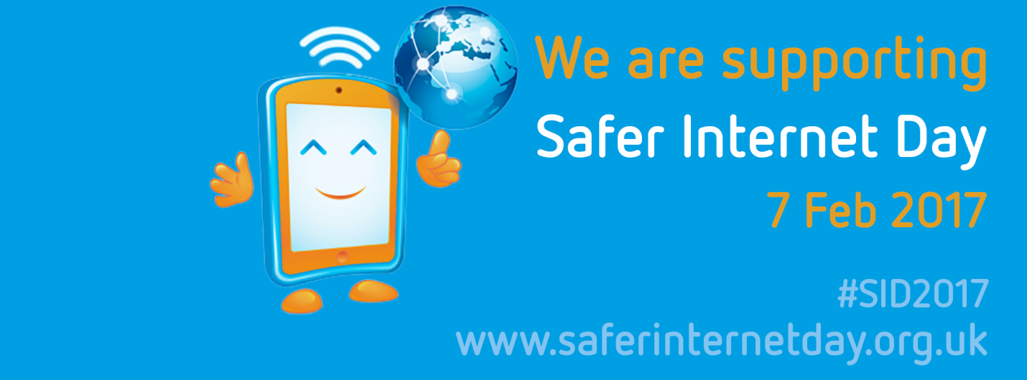

Safer Internet Day – Tues 7th Feb 2017

Safer Internet Day 2017 will be celebrated globally on Tuesday 7th February with the theme ‘Be the change: Unite for a better internet’. Co-ordinated in the UK by the UK Safer Internet Centre (a partnership of three leading charities; Childnet, the South West Grid for Learning and the Internet Watch Foundation), the celebration sees hundreds of organisations get involved to help promote the safe, responsible and positive use of digital technology for children and young people.

Parents and carers can help to create a better internet by:

- maintaining an open and honest dialogue with their children about their online lives,
- supporting them with their personal development online
- helping them to deal with any concerns or issues
- seeking out positive opportunities to engage with their children online
- helping their children to find and use good quality digital resources.

They can help to respond to the negative by:

- staying engaged with their child’s online activity (as appropriate to their age),
- modelling positive online behaviours themselves,
- reporting any inappropriate or illegal content they find.

Safer Internet Day is an opportunity to promote the positive uses of technology and highlight the role we all play in creating a better and safer online community. Young people, parents, carers, teachers, social workers, law enforcement, companies, policymakers and wider communities are all encouraged to get involved. For more information, tools and resources visit www.saferinternet.org.uk
“Safer Internet Day is celebrated in over a hundred countries.”
Facebook: Parents Portal
FaceBook have recently launched a Parents Portal – https://www.facebook.com/safety/parents. The portal is designed to help parents to get the most out of their FaceBook account and also provides advice and tips and about how they can keep themselves and their children safe online.

The average age of someone who plays games is 31 years old and most play on a console. Do you know who your child is playing with online?

Latest Social Media Trend - Live Streaming
The latest social media trend is the option of live streaming with the most popular apps (including Facebook, Instagram & Snapchat) offering this service. This feature essentially allows users to broadcast live to the particular app. Live streaming should be used with caution. There are concerns about the information strangers could obtain from these streams (such as age, location etc.) and it is important to remember that once a video is streamed (and posted) it is very difficult to deleted and even when a video is deleted users will never know who has already taken a copy.

Apps in Focus: Dubsmash

Dubsmash is a video messaging application for iOS and Android. Through the application users can choose an audio recording of a well known quote or song from a list and record a video of themselves lip syncing it.

Users must be over 13 and have permission from their parent or legal guardian but the Dubsmash terms of service advise parents that the service is not intended for children under 18 as content is user generated and may not be suitable for children.

Musical.ly (Age Limit 13+)
Musical.ly is a video social network for creating, sharing and discovering short videos.

As well as creating their own videos, users can use this app for group video chats, live streaming to their followers and for sharing their videos across other social networks such as Instagram.
Is your child using this app? Musical.ly have a parent section on their website which provides you with lots of useful information including how to make an account private (so that any followers must be approved) and also how to block users. http://musicallyapp.tumblr.com/parents)

