The Task:
The children were given just 45 minutes to create their own piece of creative writing, in whichever genre they wanted, based on the stimulus picture below.

First prize wins 300 house points, second prize wins 200 house points, and third prize wins 100 house points.

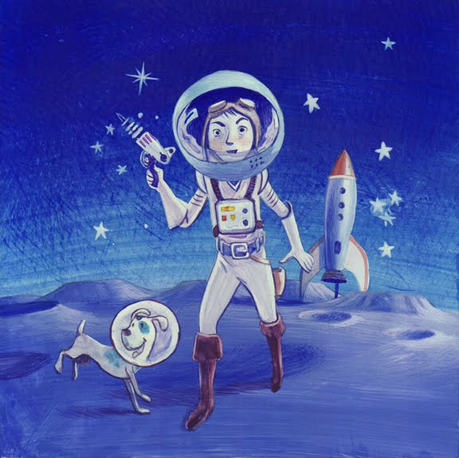

Here are the winning entries:

First Prize (RMc)

Amazing Adventure

I woke up one morning,
And slowly got out of bed,
Then I looked outside my window,
And something popped into my head.

That something was a dream,
I thought it would never be real,
But then I stopped and realised,
How awesome it would feel.

So I got my coat and slippers on,
And ran all the way down the stairs,
I also started to think for a moment,
That I was going to be the one who mostly cares.

My amazing space adventure,
Is going to be so cool,
I’d be rich and famous,
And have a giant swimming pool.

But then it came upon me,
That I don’t have a rocket,
I wish it was that easy,
For me to pull one out my pocket.

After that I wished and wished,
For a rocket to come to me,
It only took a few seconds,
For a rocket I could see.

So I happily climbed into my rocket,
I hope we will get there soon,
I will always remember the day,
When I travelled to the Moon.

Second Prize (RO)

Dear Diary,

You wouldn’t believe what happened today! I woke up and my owner, Lizzy, was dressed in some weird suit with what looked like a fish bowl on her head. I didn’t know what was going on! Then, she tried to put a fish bowl on my head as well! I tried to run, but she caught me before I even started. She got me on my leash and pulled me out of the door. Wondering what was going on, I walked beside her, trying to spot anything peculiar. We stopped outside a gargantuan warehouse. As we walked inside, a man came up to us and said to Lizzy “Are you ready for this?”. I was thinking “Ready for what? What’s going on?” It was really noisy in there, it was really scary. She took me off my leash and picked me up while starting to walk towards a massive tube with a red point at the top. We went inside of it and she strapped me into a seat and got into her own.

Anyway, I’ll speak to you later when I know what’s happening. See you later!

Storm the dog.

Third Prize (GC)

NEW PLANET DISCOVERED!

There has been a new planet discovered by a man called Mark, aged 20, and his dog, Bruno.

He is the first to walk on this planet with a dog and take it into space. We spoke to the astronaut earlier and asked him how it felt to be the first person to discover this planet and how he got there.
“Well, it feels amazing to have discovered this fantastic new planet! I got here on the 28th July, I’m so happy we got here safely. We are going to get home on the 1st August”

We all hope Mark and Bruno get home safe and have a good journey.

