Malvern Primary School

Online Safety Newsletter: April 2019

Online Challenges

There are lots of challenges that circulate across the Internet, some funny (do you remember the mannequin challenge?) but some can be frightening. We won’t mention the name of the most recent one (which some have suggested was now a hoax).

With challenges, the consensus is not to introduce your child to them by asking them about them so start with a general chat about being online. Ensure your child knows that if they do see anything they don’t like online then they should talk to you or another trusted adult.

It is so important to have regular chats with your child about their online life.

Further information: https://www.commonsensemedia.org/blog/viral-youtube-challenges-internet-stunts-popular-with-kids
Instagram

Children should be over 13 years of age to access Instagram. According to the latest NSPCC research, there has been a 200% rise in recorded instances in the use of Instagram to target and abuse children in an 18 month period.

It is important that if you do choose to allow your child to use Instagram that you enhance the privacy of their account. Go to account settings:
- Set account to private.
- Story control – either set allow message replies from ‘followers you follow back’ or turn off.
- Don’t allow sharing of your photos and videos from your story.
- Comment Controls – select hide offensive comments.

Talk to your child about the ‘Search & Explore Tab’ and who your child is following. There are accounts set up on Instagram that can include graphic content and they may come across inappropriate content and language.
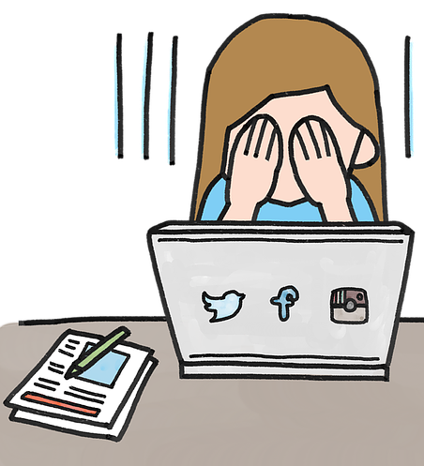
Ensure your child knows how to report posts and people as well as how to unfollow and block people, delete and turn off comments. More information can be found here: https://wellbeing.instagram.com/safety. You are also able to report photos, videos, comments or profiles that are bullying or harassing via Instagram’s help centre.

Make sure your child understands that there is a risk that content they upload can never be removed (other users can screenshot it for example) so they must only share content that they are comfortable with you seeing. Ensure that they know that they should talk to you or another trusted adult if they have any concerns.
What games are your children playing?

Children often ask to play games that they’ve heard about or that their friends are playing but are they really appropriate? It is really important to research games that they ask to play before you say yes, for example, check the age/PEGI rating, does it include a chat facility, does it have any parental controls and can you play the game first to see what it entails?

Here are some examples of games that we’ve heard primary aged children are playing when in fact they are too young to:

SlenderMan
Most versions 12+

SCP Containment Breach
PEGI rating 16+
Free survival horror game

Overwatch
PEGI rating 12+
Team-based shooter

Call of Duty
PEGI rating 16+ or 18+
Warfare game

Assassin’s Creed
PEGI rating 18+
Action Adventure game

Childnet has a designated area to cover Gaming and includes what you need to know about gaming and how you can support your child based on their age:
https://www.childnet.com/parents-and-carers/hot-topics/gaming
YouTube

You should be 13+ to use YouTube. Lots of inappropriate content can be found on YouTube and it relies heavily on users flagging content that violates the terms and conditions of their service. What can you do to make it safer for your children?
- Turn on Restricted mode – this mode restricts the availability of mature content.
- Sit with your child and see what they are watching.
- Ensure your child knows how to report content.
- Make sure your child understands that they can talk to you if they see anything upsetting online.

YouTube Kids is also available with the option to select the shows you prefer your child to watch, however inappropriate content has also been found on here too. Services such as Netflix, Amazon Prime and BBC iPlayerKids are a great alternative containing lots of children’s programmes.

WhatsApp – group messaging

You must be at least 16 years old to register for and use WhatsApp.

WhatsApp is a free messaging app that allows you to send messages and videos. WhatsApp has a Group chat function which allows up to 256 people to be added. Groups are set up by one person (who is the admin) and everybody in the group, even if they’re not one of your child’s phone contacts will be able to see all messages sent. If your child is added to a group with someone they have previously blocked, that person can still see their messages and send them messages through the group.

WhatsApp has been used in instances of online bullying, for example sending nasty messages or sharing images of other children without their permission in order to embarrass them.
WhatsApp does offer the ability to block and report contacts.
Does your child have a Playstation?

Trend Micro Kids Safety is a paid for subscription (30 day free trial available) that can prevent the internet browser from opening websites unsuitable for children. It will block websites that fall into the categories: adult (sexual), alcohol, tobacco, illegal drugs, crime, cults, gambling and racism. Further information:

https://esupport.trendmicro.com/en-us/home/pages/technical-support/psp-ps3-ps4-security/home.aspx
Apex Legends – PEGI Rating 16+

Apex Legends does have similarities to Fortnite but it is important to know that it has been rated by PEGI as 16+. This means children under the age of 16 should not play this game. “This game has received a PEGI 16 because it features sustained depictions of violence towards human characters and moderate violence.” (Source: https://pegi.info/) PEGI does not take into consideration the chat features.

Apex Legends was released in February and has already hit over 50 million players worldwide. This is another multiplayer battle royale style video game whereby teams of 3 players compete against other teams to be the last team standing. It is available on Playstation 4, Xbox One and Origin for PC.

In-Game Currency
Whilst the game is free to play, players are able to make in-game purchases using ‘Apex Coins’. These packs range from £7.99 to £79.99! They can be used to advance play so children may wish to purchase them. We’d recommend password protecting your account and/or setting up a child account to ensure your child can’t make any purchases without your consent.
Books to read with your child

Jeanne Willis and Tony Ross have published Chicken Clicking and Troll Stinks and the recently released #Goldilocks. These are fantastic picture board books specifically aimed at younger children (KS1) but can equally be enjoyed by older children.

Chat
As players work in teams of 3, your child may be in a team with people they don’t know and potentially at risk from explicit language or harassment.

Reporting Players
As with all online games, you must always ensure that your child understands how to report abusive players. Full instructions are available here:
Does your child have a Nintendo Switch?

Did you know that you can download an app to give you additional parental features and settings? This article shows you how to do this as well as how to use the existing parental controls:
https://www.commonsensemedia.org/blog/parental-controls-nintendo-switch

https://help.ea.com/uk/apex-legends/apex-legends/?category=report-concerns-or-harassment

Further information
- https://www.commonsensemedia.org/blog/parents-ultimate-guide-to-apex-legends
- https://www.net-aware.org.uk/news/apex-legends-what-you-need-know/

We would recommend that the age restrictions set by this game are adhered to. Play the game yourself first so you can assess whether you think it is appropriate or not and if not, chat to your child and explain why you think this.

