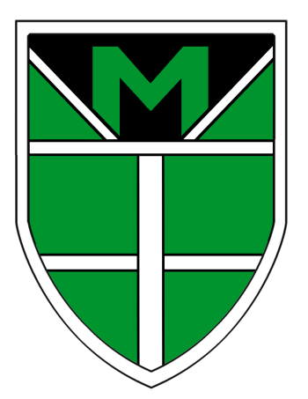

Malvern Primary School
Parent Code of Conduct

As partners, our parents will understand the importance of a good working relationship to equip children with the necessary skills for adulthood. For these reasons we continue to welcome and encourage parents/carers to participate fully in the life of our school.
The purpose of this document is to provide a reminder to all parents, carers and visitors to our school about the expected conduct. This is so we can continue to flourish, progress and achieve in an atmosphere of mutual understanding.

Guidance
As well as following the guidance set out in our Home-School Agreement, we expect parents, carers and visitors to:
- Respect and model the caring ethos of our school whenever on school premises or when communicating directly with the school.
- Understand that school staff and parents need to work together for the benefit of all
- Demonstrate that all members of the school community should be treated with tolerance and respect and therefore set a good example in their own speech, conduct and behavior.
- Seek to clarify a child’s version of events with the school’s view in order to bring about a peaceful solution to any issue.
- Correct own child’s behaviour especially in public where it could otherwise lead to conflict, aggressive behaviour or unsafe behaviour.
- Approach a member of school staff to help resolve any issues or concern.

In order to support a peaceful and safe school environment the school cannot tolerate parents, carers and visitors exhibiting the following:
- Attempts to gain entry to any part of the school in disregard of procedure or without permission and appropriate supervision.
- Disruptive behaviour which interferes or threatens to interfere with the operation of a classroom, an employee’s office, office area or any other area of the school grounds.
- Using loud/or offensive language, swearing, cursing, using profane language or displaying temper.
- Threatening to do actual bodily harm to a member of school staff, Governor, visitor, fellow parent/carer or pupil regardless of whether or not the behaviour constitutes a criminal offence.
- Damaging or destroying school property.
- Abusive, persistent or threatening e-mails or text/voicemail/phone messages or other written communication
- Defamatory, offensive or derogatory comments regarding the school or any of the pupils/parent/staff, at the school on Facebook or other social sites. Any concerns you may have about the school must be made through the appropriate channels by speaking to the class teacher in the first instance, the Head teacher or Curriculum Team Leader, so they can be dealt with fairly, appropriately and effectively for all concerned. If you are not happy with the outcome, you can also ask for a copy of the Complaints Procedure and follow the steps enclosed.
- The use of physical aggression towards another adult or child. This includes physical punishment against your own child on school premises.
- Approaching someone else’s child in order to discuss or chastise them because of the actions of this child towards their own child. (Such an approach to a child may be seen to be an assault on that child and may have legal consequences).
- Smoking and consumption of alcohol or other drugs whilst on school property.
- Animals (other than assistance dogs) being brought onto school property.
Should any of the above behaviour occur on school premises the school may feel it is necessary to contact the appropriate authorities and if necessary, even ban the offending adult from entering the school grounds.
We trust that parents and carers will assist our school with the implementation of this code of conduct and we thank you for your continuing support of the school

Inappropriate use of Social Media
Social media websites are being used increasingly to fuel campaigns and complaints against schools or to share inappropriate information, e.g. naming children involved in incidences, sharing confidential information regarding an aspect of school life, making allegations or accusations or sharing false news. Malvern Primary School considers the use of social media websites or Apps in this way as unacceptable and not in the best interests of the children or the whole school community. Any concerns you may have must be made through the appropriate channels by speaking to the class teacher, the leadership team or the Headteacher, so they can be dealt with fairly, appropriately and effectively for all concerned.
In the event that any pupil or parent/carer of a child/ren being educated in Malvern Primary School is found to be posting libelous or defamatory comments on Facebook or other social network sites or Apps, they will be reported to the appropriate ‘report abuse’ section of the network site. All social network sites have clear rules about the content which can be posted on the site and they provide robust mechanisms to report contact or activity which breaches this. The school will also expect that any parent/carer or pupil removes such comments immediately.
In serious cases the school will also consider its legal options to deal with any such misuse of social networking and other sites. Additionally, and perhaps more importantly is the issue of cyber bullying and the use by one child or a parent to publicly humiliate another by inappropriate social network entry. We will take and deal with this as a serious incident of school bullying. Thankfully such incidents are extremely rare.

We would expect that parents would make all persons responsible for collecting children aware of this policy.

