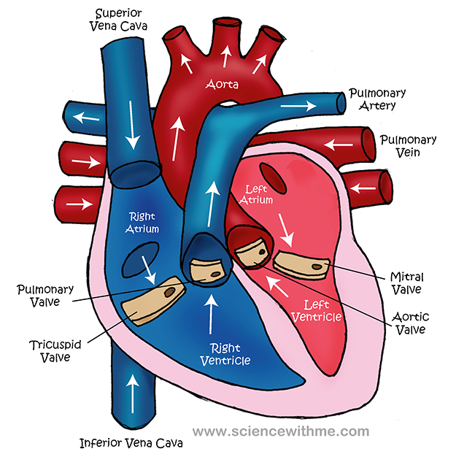

Blood flows through the **vena cava** and into the **right atrium**.

From the **right atrium** it flows to the **right ventricle**.



[](https://www.google.co.uk/url?sa=i&rct=j&q=&esrc=s&source=images&cd=&cad=rja&uact=8&ved=0ahUKEwjw1t322-_VAhWHHxoKHeCwC5IQjRwIBw&url=https://www.pinterest.com/pin/biology-projects-science-projects--515521488572070125/&psig=AFQjCNG0y6eQ4FlgT9TqxjUE27bZF_l6yQ&ust=1503658860224658)

The blood flows out through the **pulmonary artery** to the **lungs**.

Why does it travel to the lungs?

[](https://www.google.co.uk/url?sa=i&rct=j&q=&esrc=s&source=images&cd=&cad=rja&uact=8&ved=0ahUKEwjw1t322-_VAhWHHxoKHeCwC5IQjRwIBw&url=https://www.pinterest.com/pin/biology-projects-science-projects--515521488572070125/&psig=AFQjCNG0y6eQ4FlgT9TqxjUE27bZF_l6yQ&ust=1503658860224658)

Blood flows back to the **left atrium** through the **pulmonary vein.**

Why does the heart have valves?

[](https://www.google.co.uk/url?sa=i&rct=j&q=&esrc=s&source=images&cd=&cad=rja&uact=8&ved=0ahUKEwjw1t322-_VAhWHHxoKHeCwC5IQjRwIBw&url=https://www.pinterest.com/pin/biology-projects-science-projects--515521488572070125/&psig=AFQjCNG0y6eQ4FlgT9TqxjUE27bZF_l6yQ&ust=1503658860224658)

Blood then flows to the **left ventricle.**

[](https://www.google.co.uk/url?sa=i&rct=j&q=&esrc=s&source=images&cd=&cad=rja&uact=8&ved=0ahUKEwjw1t322-_VAhWHHxoKHeCwC5IQjRwIBw&url=https://www.pinterest.com/pin/biology-projects-science-projects--515521488572070125/&psig=AFQjCNG0y6eQ4FlgT9TqxjUE27bZF_l6yQ&ust=1503658860224658)

Blood flows back to the **left ventricle** to the **aorta** and around the body.