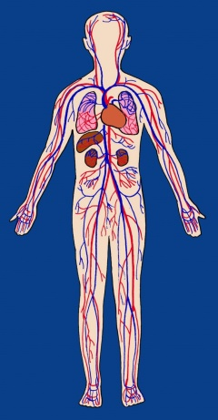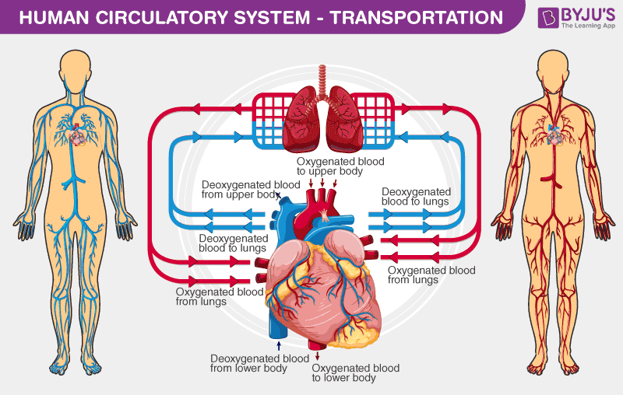[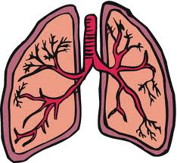](http://www.google.co.uk/imgres?q=lungs&sa=X&biw=1058&bih=477&tbm=isch&tbnid=pv0dZSvz3XVMHM:&imgrefurl=http://www.columbusck.com/our-center/news-events/&docid=b5cB2sLnhQwopM&imgurl=http://www.columbusck.com/wp-content/uploads/lungs.jpg&w=1200&h=1104&ei=PYJ7UYbvG-K-0QXZuIDIAg&zoom=1&ved=1t:3588,r:24,s:0,i:229&iact=rc&dur=1513&page=2&tbnh=179&tbnw=195&start=10&ndsp=15&tx=93&ty=78)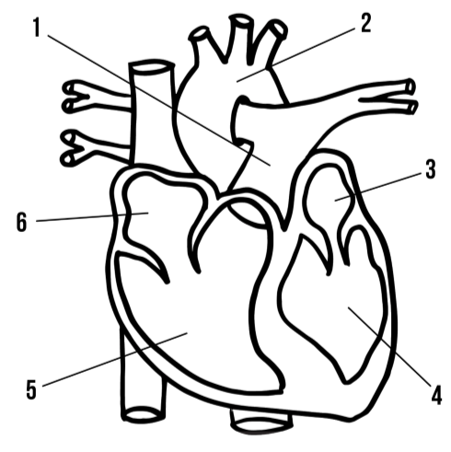

Write an explanation of the veins, arteries and capillaries.

Where I the body is blood cleaned before returning back to the heart?

Describe where the blood flows when it enters the right atrium

As the blood travels around the body what does it do?

Where does the blood go when it leaves the left ventricle?

START:

1. Label the heart.
2. Colour the valves in green.
3. Colour the left atrium and the left ventricle in red.
4. Colour the right atrium and right ventricle in blue
5. Colour the aorta in purple.

Why does the heart pump blood to the lungs?

Why is blood pumped back to the heart?

What do the colours red and blue represent?