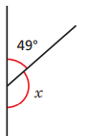  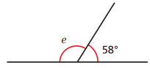  Calculate the missing straight line angles.  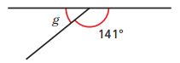  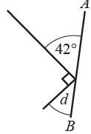  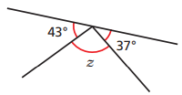  z  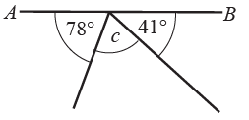  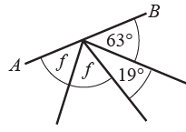  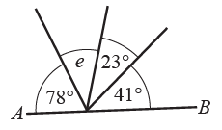 | Calculate the missing angles around a point.  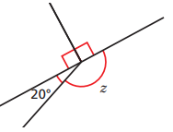  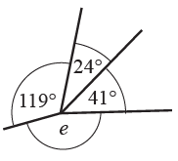  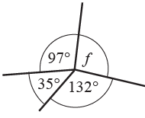  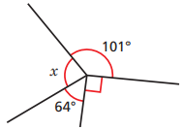  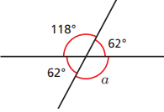  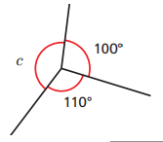
Use the information to work out the missing angles.  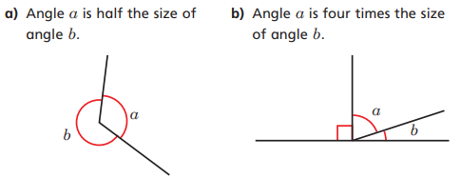 | 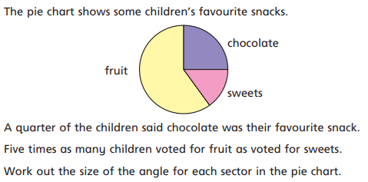

Complete the sentences.  There is ___ right angle in a quarter turn.  A quarter turn is ___ degrees.  There are ___ right angles in a half turn.  A half turn is ___ degrees.  There are ___ right angles in a three-quarter turn.  A three-quarter turn is ___ degrees.  A full turn us ___ degrees and has ___ right angles. | Jack faces the direction the arrow is pointing.  He turns half a turn.  Draw on the diagram to show the direction he now faces.  How many degrees did he turn through? | Dora faces the direction the arrow is pointing.  She turns a quarter turn clockwise.  Draw on the diagram to show the direction he now faces.  How many degrees did she turn through?
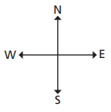  Use the compass below to answer the following questions.  Sam faces east. He turns 180°. What direction does he now face?  Lucy faces west. She turns a quarter turn clockwise. What direction does she now face?  Kim faces south. How many degrees clockwise must she turn to face east? | Here is another compass.  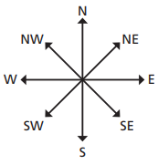  Dexter faces north-east. He turns half a turn. What direction does he face now?  Dan faces south-west. He turns 270° anticlockwise. What direction does he face now? | Complete the statements:  $\frac{1}{2}$ of a full turn = ___°  $\frac{1}{4}$ of a full turn = ___°  $\frac{3}{4}$ of a full turn = ___°  $1\frac{1}{4}$ full turns = ___°  $5\frac{3}{4}$ full turns = ___°

