Can I analyse websites to identify their credibility?
- What features do fake websites use to convince users that they are real? Explain how each feature is convincing to the untrained eye.
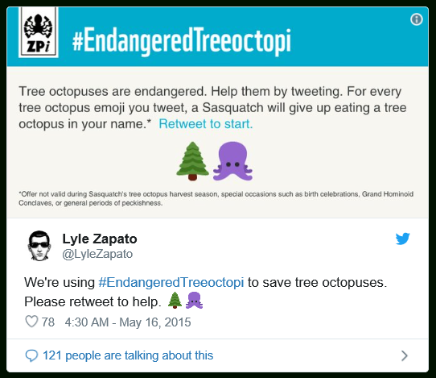


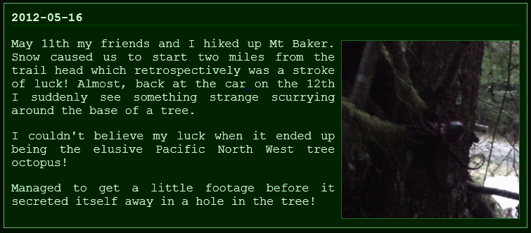

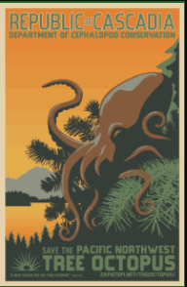
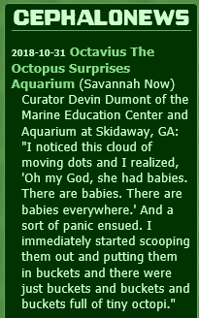

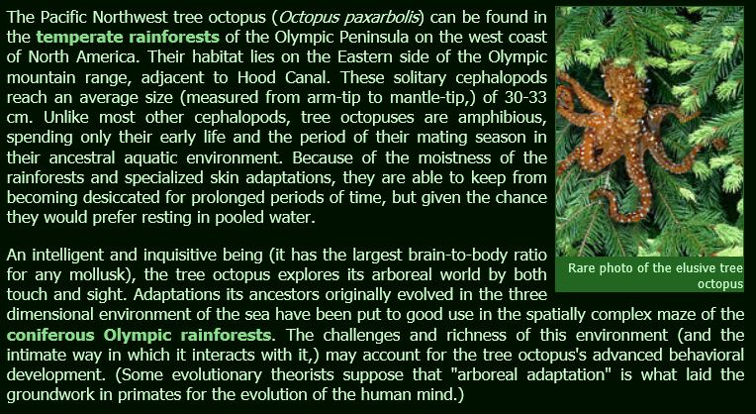

- What can you do or look at to help you identify if a website is fake?





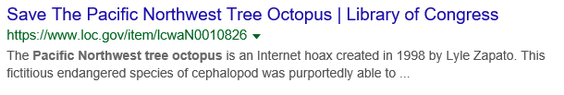

The Endangered Pacific Northwest Tree Octopus

- Where can the tree octopus been found?

- What is the average size of a tree octopus?

- Why is the tree octopus considered to be endangered?

- Give 3 ways people can help save the tree octopus?

- What is tree octopus called in the following languages:
- Dutch
- German
- Spanish

- Is it possible to have a tree octopus as a pet? Why?

- What forms of media has the tree octopus appeared in?

- Name 3 other animals of interest that the website makes links to.

