Who was Charles Darwin?

Charles Darwin was an English naturalist who changed the way humans viewed themselves and the world around them through his amazing ideas on evolution and natural selection.

Using the internet, your task is to find out more about Darwin and his theories, and record your research in a fact file. Listed below are possible subheadings you may want to use to present your findings.

Think carefully about how you will present the information so that it is clear, precise and appealing to the eye.

- Full Name:
- Date and Place of Birth:
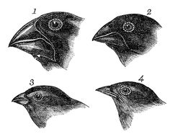
- Famous for:

- Who was Charles Darwin?
- Charles Darwin’s life
- What did Darwin discover that was so significant?
- Voyage of HMS Beagle
- The Galapagos Islands
- What is the Theory of Evolution and Natural Selection?

