Taste some fish
This week we have been looking at sea creatures. Why not have a go at tasting some fish that you wouldn’t normally eat? Can you describe what it looks like? Tastes like? Smells like?

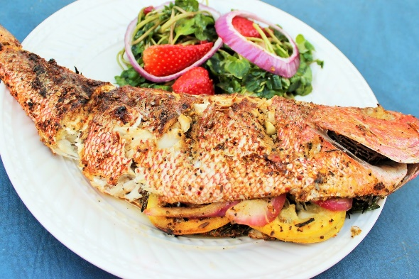 Red Snapper

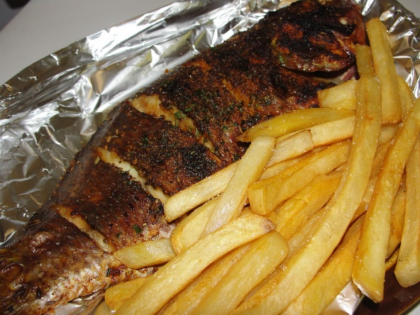 Tilapia

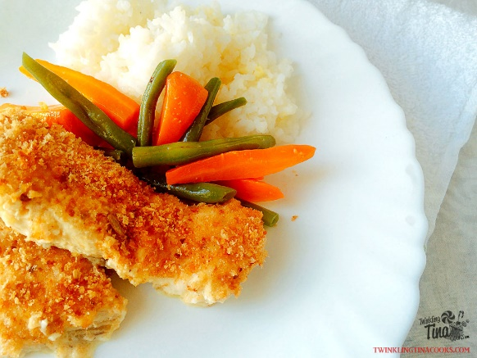 Basa

