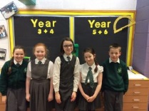Hello and welcome to this bi-weekly edition of Maths is Everywhere.

So, let’s begin….

This week we have undertaken a flash maths survey in both KS1 and KS2. The results were very interesting.

**KS1**

|  |  |
| --- | --- |
| Do you enjoy Maths? | 83.8% approval rating |
| Are lessons a challenge? | 67.2% approval rating |
| Do you try and work by yourself? | 76.2% approval rating |
| Do you learn in every lesson? | 75.6% approval rating |
| Is Maths fun? | 93.6% approval rating |



**KS2**

|  |  |
| --- | --- |
| Do you enjoy Maths? | 85.4% approval rating |
| Are lessons a challenge? | 70.2% approval rating |
| Do you try and work by yourself? | 81% approval rating |
| Do you learn in every lesson? | 85.2% approval rating |
| Is Maths fun? | 87.6% approval rating |

The results obtained are very encouraging and an excellent starting point. However, we will be looking to improve the results, especially with regard to challenge around the school.

You can follow us on the School website and on Twitter using:

@MathsatMalvern

**What’s Been Happening?**

Over the last fortnight the children have competed in a chess competition at St. Margaret Mary’s Primary School. The children performed outstandingly and had lots of fun.

In other news, the next Maths Competition will take place on 1st March including: Halsnead, St. Brigids and Huyton with Roby. Go Malvern!!!

**My Role as a Maths Ambassador**

This week we have interviewed one of our own, and asked Lydia O’S what it’s like to be a Maths Ambassador and what challenges and rewards she comes across.

Q1: What role do you have as a Maths Ambassador?

In my role, I help to promote Maths throughout the whole school. I have time to help in many different classes and help run the competitions. We also have weekly meetings with Mr. Morland to discuss what we are doing for the week.

Q2: Is your new role good?

Yes, I really enjoy being able to help many different children and I like the responsibility of helping children and teachers make Maths better in the school.

Q3: What challenges do you face as a Maths Ambassador?

Sometimes, I feel under-pressure when people are finding challenges difficult but I try my best to explain what to do.

Q4: What difference are you making in school?

I am encouraging and promoting Maths, it is something we do every day and Maths is everywhere; it is in every lesson and every job.

Q5: What would you like to change about Maths in the school?

I think I would like to change how some children think about Maths and try to increase the level of difficulty.

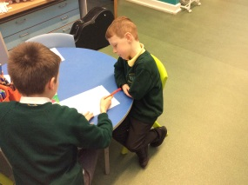**Puzzle Page**

Here are this week’s problems.

**Children in Year 1 and Year 2**

In this problem use the digits in the question to solve the problem

Each missing digit in these calculations is **1, 2, 5 or 3**

Write in the missing digits. You may use each digit more than once.

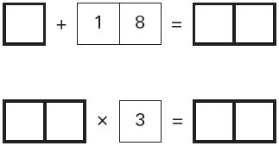



**Children in Year 3, 4, 5 and 6**

Here are five number cards.



A and B stand for two **different** whole numbers.

The sum of all the numbers on all five cards is 30

What could be the values of A and B?



**Parent Puzzle**

BIDMAS Laws

Solve each calculation:

6 + 9 x 4

17 – 5 x 3

(9 x 8) - $7^{2}$

**Maths Pictures from the week**

26.01.18

