[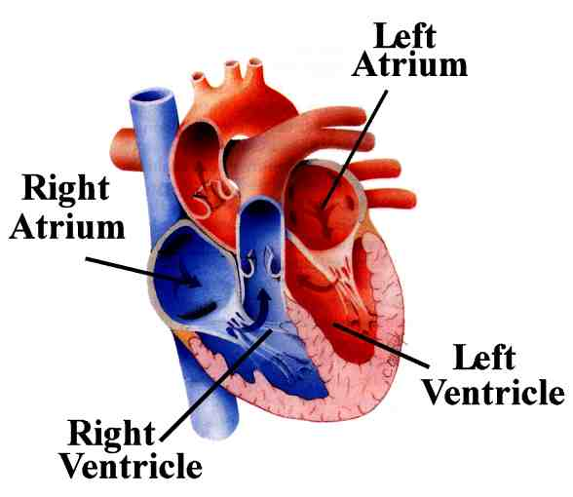](http://www.google.co.uk/url?sa=i&rct=j&q=&esrc=s&source=images&cd=&cad=rja&uact=8&ved=0ahUKEwjAsf-p1e_VAhWJvBoKHbFcAm4QjRwIBw&url=http%3A%2F%2Fwww.starsandseas.com%2FSAS%2520Physiology%2FCardiovascular%2FCardiovascular.htm&psig=AFQjCNEA6gGoKYqRkmp4KzKX0IVKX1SOVw&ust=1503657088589612)Have you ever watched as your mom or dad pumps gas into your car? You may not realize it, but the most vital part of your body— your heart—is simply a fancy pump.



The heart is a muscular organ found in all animals with a circulatory system. Your heart is the most important organ in your body as it pumps blood through vessels to each part of your body. The blood is pumped through 60,000 miles of blood vessels; that’s the same as driving around the Earth’s circumference nearly two and a half times!

The heart is located a little to the left of the centre of your chest (between your lungs) and is about the size of your fist. It is situated behind your ribcage for protection; however you can feel the beat of your heart through your pulse. A good place to find your pulse is on your wrist where there is a large artery, however can also be found at the inside of your elbow, nexk, back of your knew and foot. If you lightly hold two fingers on your wrist just below your thumb you can feel your heart beat. The average human heart beats at 80 beats per minute. However, this can change

depending on your age, how fit you are and how you are feeling.

As your heart beats, it makes a characteristic ‘lub-dub’ sound. This sound is created by the contraction and relaxation of the heart. If your heart beats faster, this tells you that your heart is working harder to pump blood (filled with oxygen and nutrients) around your body. Blood is transported around your body through a network of tubes called arteries and veins. Arteries carry blood away from your heart and veins carry it back to the heart.

This process is carried out in the 4 chambers that make up your heart. Your blood first enters the two upper chambers and is then pushed by the heart to the lower chambers. Your blood is then pumped to your lungs where it picks up oxygen before being pumped around the body.

With your heart working so hard to keep you alive, it is important that you work hard to keep your heart healthy. Eating plenty of fruit and vegetables, ensuring not too eat too much salt or fatty foods and exercising regularly are just a few ways you can have a happy heart.

1. What does the author suggest by saying the heart is ‘the most vital part of your body’?
2. Write a definition of what the heart is and its job. Use the text to support your definition.
3. **‘The blood is pumped through 60,000 miles of blood vessels; that’s the same as driving around the Earth’s circumference nearly two and a half times!’**

Why does the author make this link between the length of blood vessels and driving around the earth?

1. In what part of your body is your heart located? Why is it located there?
2. Name 3 places that your pulse can be found? Where is best?
3. What enables you to feel your pulse?
4. The text states that your heart rate may change depending on ‘how you are feeling’. How do you think your feelings may affect your pulse rate?
5. How is blood transported around your body?
6. Complete the Venn diagram to compare and contrast the function of arteries and veins.

**Arteries**

**Both**

**Veins**

1. How can you ensure that your heart is kept in a healthy condition?