**The Titanic – Who was responsible?**

Read the information provided on the following pages about who may be to blame for the sinking of the Titanic.

Once you have read the information, your task is to write two paragraphs.

One explaining who is most likely to be responsible and why.

One explaining who is least likely to be responsible and why.

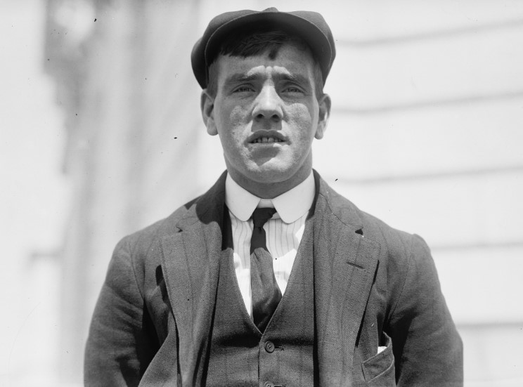

**Frederick Fleet – Look Out (survived)**

It was nearly midnight. I was on the night shift in the crow’s nest. The sea was as smooth as a pond and the sky brilliant with stars. It was freezing. All I could see was my breath. I didn’t have my binoculars because they’d been locked in a cupboard and no-one knew where the keys were.

Suddenly, I spotted the towering grey mountain of ice dead ahead. It came out of nowhere. I would have seen it sooner if I’d had a pair of binoculars!

I rang to the bridge as fast as I could. “Iceberg, right ahead!” I shouted down the telephone. And then I waited. The ice berg was only a mile away. There was nothing I could do now. I braced myself against the mast for the collision.

Was Frederick Fleet most responsible for the loss of life on Titanic?

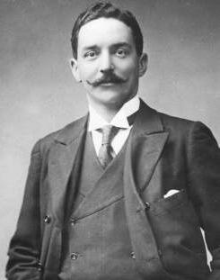

**Bruce Ismay – Manager of White Star Line (survived)**

Some people say they heard me persuading Captain Smith to go faster. This is not true. I have always said that it is not the speed of the ship that matters, but how luxurious it is. It was certainly not my fault that the ship was travelling so fast when we hit the iceberg!

Titanic had more lifeboats than it legally required. I was even happy to include four collapsible boats. It still wasn’t enough, I accept that, and I’m terribly sorry for those who didn’t get to a boat, but the ship sank so quickly, we wouldn’t have had time to fit any more people in anyway!

I helped as many people as I could into boats before I got in one myself. There were no more women or children around. I felt that I could be of more help to the survivors than to those still on the ship. From now on, White Star Line will include enough boats for everybody.

Was Bruce Ismay most responsible for the loss of life on Titanic?

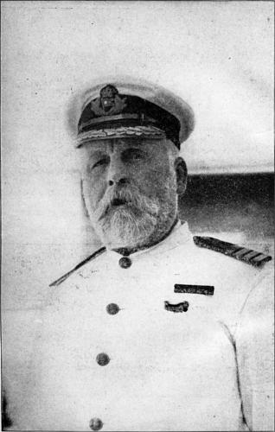

**Edward Smith – Captain (died)**

I was a highly experienced captain. In fact, I even helped to avoid a disaster in Southampton as the Titanic set sail! The size of the ship meant that when it moved forward, it sucked a smaller boat towards it. It was thanks to me that we swerved out of the way in time!

The only reason we were travelling so quickly when we hit the iceberg was because the water was so calm and the sky so clear. My wireless operator did mention that there was ice in the area, but it is usually much smaller than the berg we hit. If I’d have known, I’d have slowed down, of course!

When we sank, I helped as many women and children into boats as I could. The last anyone saw of me was helping a child into a boat, then drifting away into the icy waters...

Was Captain Smith most responsible for the loss of life on Titanic?

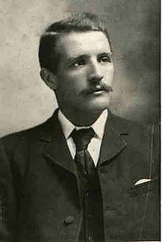

**William Murdoch – Chief Officer (died)**

I was on the bridge when the call came through – “iceberg right ahead!” I immediately ordered the ship to turn starboard (left) in the hope that we would avoid hitting it. I then sent a call through to the engine room, telling them to reverse the engines to slow us down. I closed all of the watertight doors below decks to seal any punctured compartments.

There are some people who think that if we had hit the iceberg straight on, it would only have damaged the front of the ship and we’d stay afloat. But my training has always taught me to try to avoid hitting icebergs.

Maybe if I hadn’t reversed the engines, we would have turned quicker, I don’t know! But I did everything I could.

Was Officer Murdoch most responsible for the loss of life on Titanic?

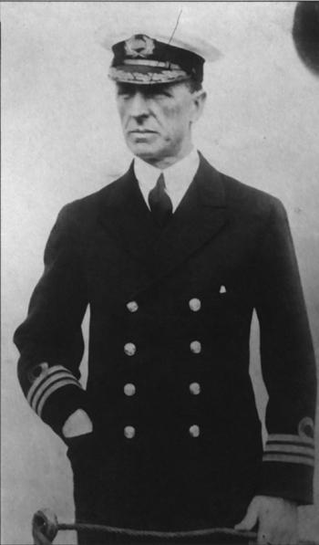

**Stanley Lord – Captain of S.S. Californian**

We had stopped our ship, the S.S. Californian, for the night because the sea was filled with pack ice.

Before we went to bed, our telegraph operator sent a message to a large ship about ten miles away, warning it that there was ice about. It was the Titanic. They told us to stop messaging them, as they had a backlog of messages to send to passengers’ relatives in New York.

Later that night, my Second Officer noticed rockets being fired from the Titanic. He tried to signal using a flash light, but got no response. We never thought to switch the radio on. Several more rockets were fired, and the ship did look rather strange. Then, gradually, it seemed to disappear, as though it was sailing away... I decided to try to get in touch with them in the morning.

I didn’t know it had sunk, otherwise I would have helped!

Was Captain Stanley Lord most responsible for the loss of life on Titanic?