Basic Angles Rules Practice

For each question find the missing angle and give a reason for your answer.
(Don’t forget to show your working!)

1. | 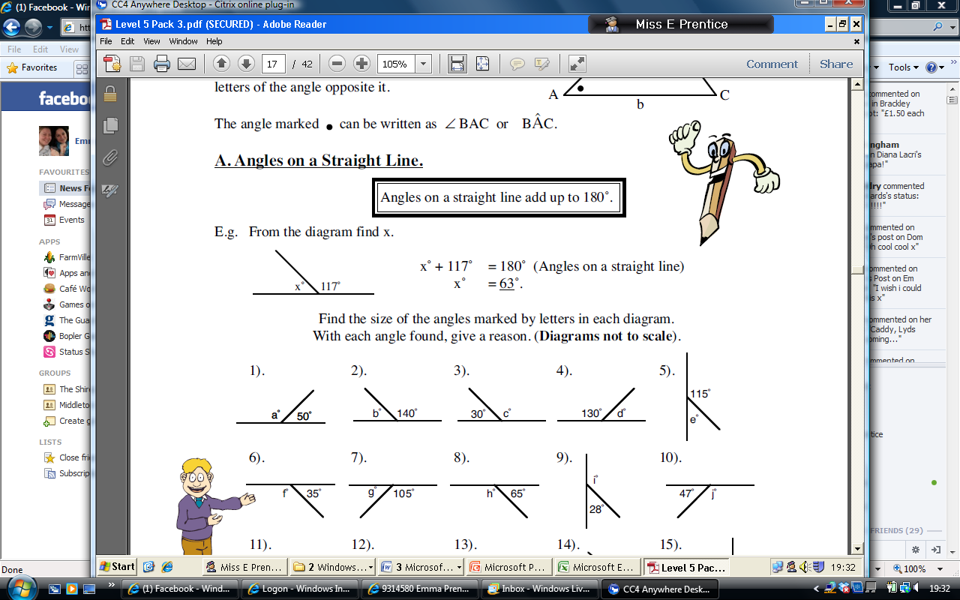 | 2. | 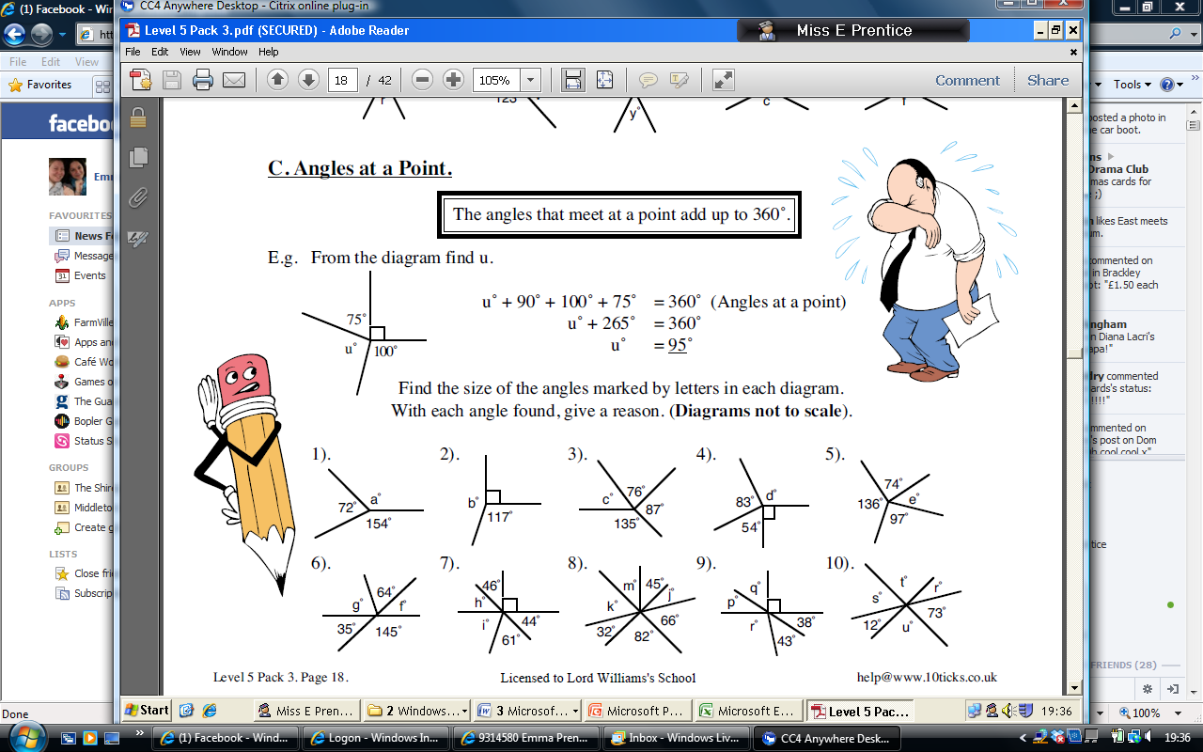 | 3.
4. | 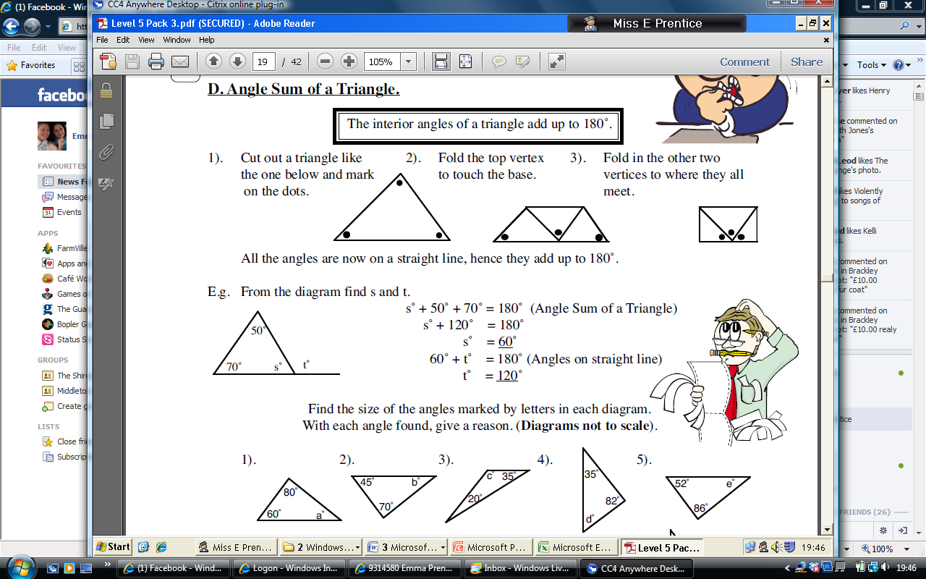 | 5. |  | 6.
7. |  | 8. |  | 9.
10. |  | 11. |  | 12.
13. |  | 14. | 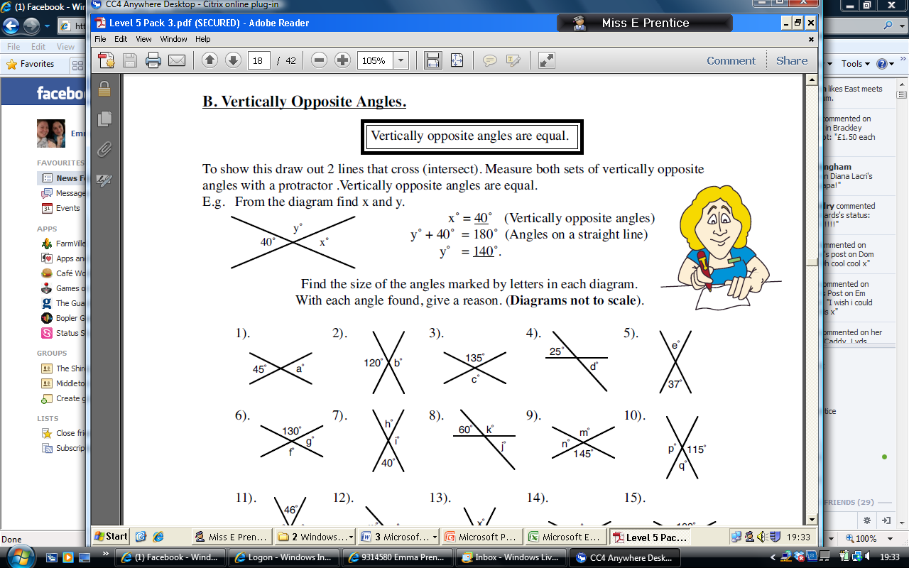 | 15.
Challenge Questions
Give reasons for every angle!
16. | 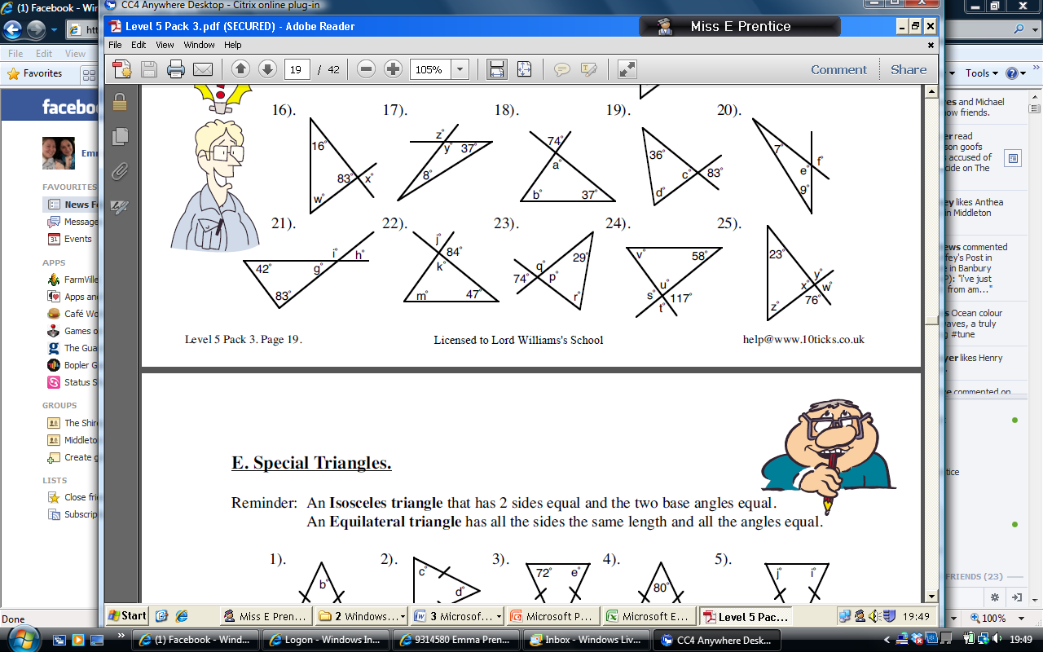 | 17. | 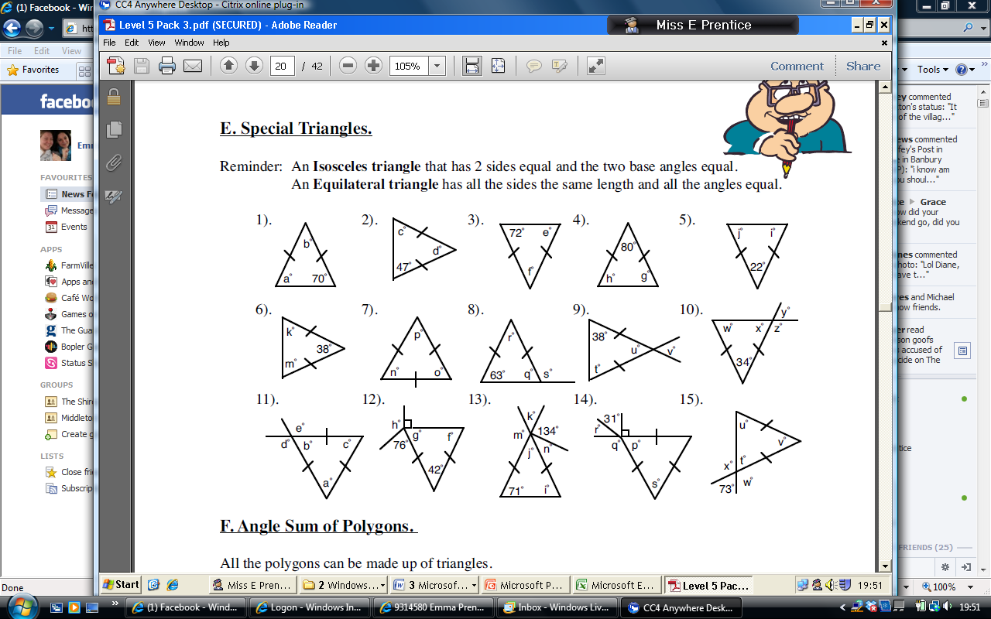 | 18.
19. |  | 20. |  | 21.

