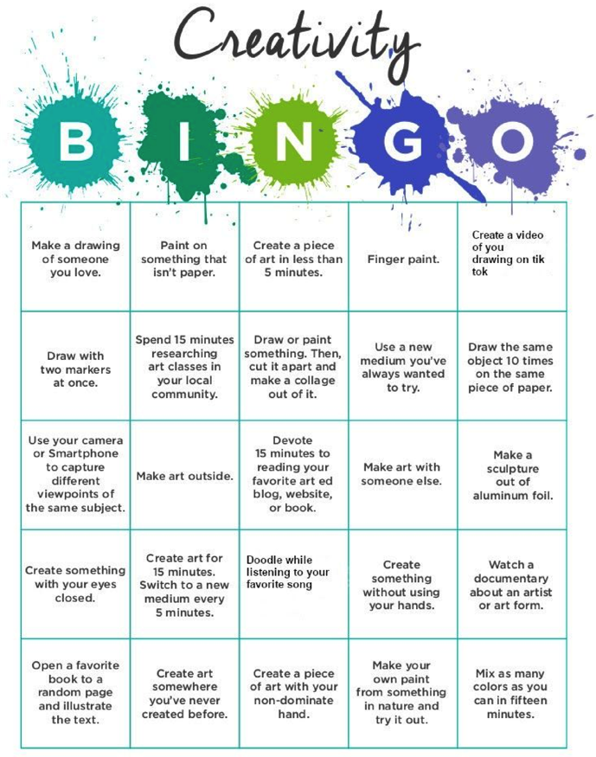
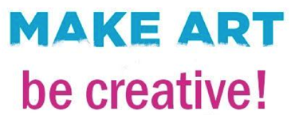
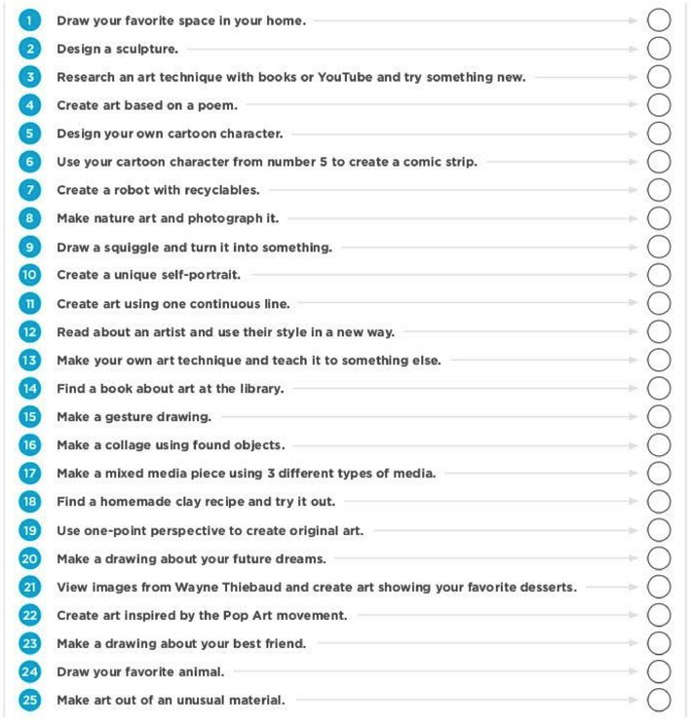
3
.
S
K
E
T
C
H
B
O
O
K

d
o
o
d
l
e
s

y
o
u

c
a
n

d
o

a
t

h
o
m
!

Create Outdoor Art
​ Check out the work of Andy Goldsworthy who creates art from nature! See if you can create your own.

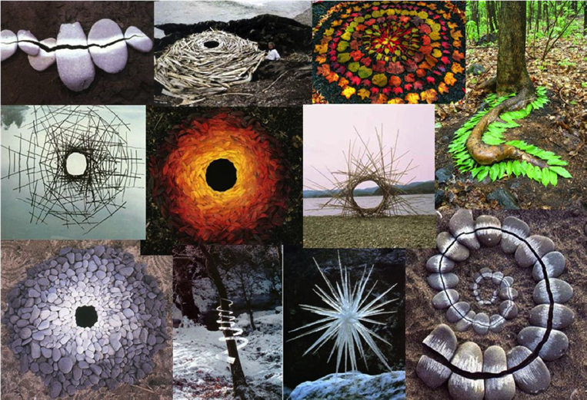

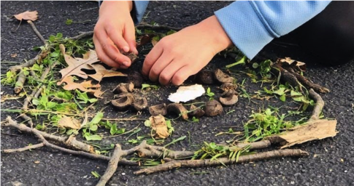

Want even more creativity!? Here are a few digital resources you can check out!
- Art Contests: Museums: take a virtual field trip to museums around the world and even stream Operas on your phone/computer/tv
- Art Games: compete against yourself and others
- Digital Art: create art on your device
- Art Education: learn about art
- Art at Home: Art tutorials and prompts for you to create where you are
Art Contests | Museums | Art Games | Digital Art | Art Education | Art at Home
Doodle for  Google | Google Arts &  Culture: Virtual  Museums | Quick, Draw! | Just a Line | Interactive Color  Wheel | How to Draw ​ / Free Daily LIVE webcasts
Science without  Borders | Online Tours:  The Louvre | Mondrian  Squares  Challenge | Mandala Creator | Color Theory | Illustration  Drawing
Impact of Conflict | The Museum of the World | Autodraw | Silk | Cubism | Daily LIVE art activities
State Fish Art  Contest | Guggenheim  Online Collection | Mondrimat | Digital Sand Art | Pintura | Watercolor  Tutorials
Guadalupe  Mountains | Museum of  Natural History | Street Art | Create Comics | The Caves of  Lascaux | Bullet Journaling
National Fossil  Day | Salvador Dali  Museum | Art Puzzle | Picasso Head | METKids Time  Machine | Make an Art  Studio
Ocean  Awareness | Air Force  Museum | Hieronymus  Bosch Invaders | Matisse Drawing  Room | National Gallery of Art Interactives | Drawing at home prompts
Embracing Our  Differences | Nightly Met  Opera Streams | Queensland Art  Games | Patterns of  Infinity | Destination  Modern Art | Youth Art Month  Creative Sprint
 | Digital Concert  Hall |  | Haring Coloring  Book | Tate Kids | Cassie Stephens
 | Moma Learning |  | Patterns | Art Quizzes | Procreate  Tutorials

