Use the classification key to place the animals in the correct place.

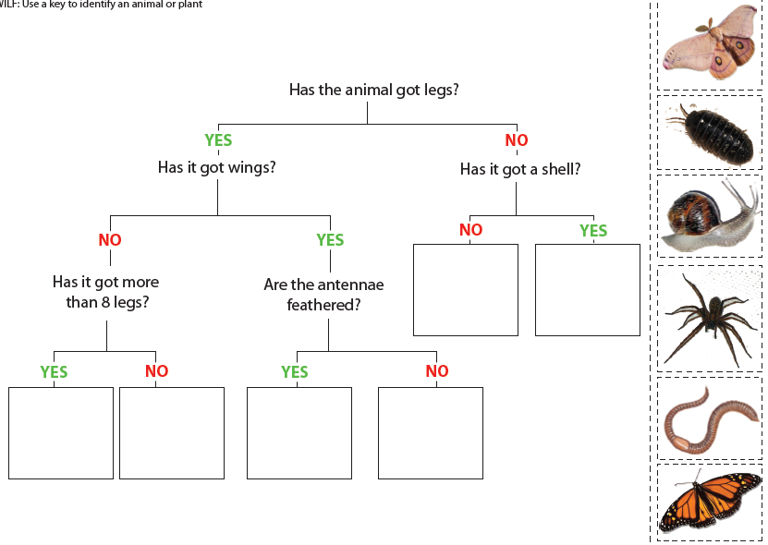

Fill in the classification key with appropriate questions

