En
English Tests

Grammar, punctuation and spelling
Paper 1: Short answer questions
KS2

First name
Middle name
Last name
Date of Birth | Day |  |  | Month |  | Year
School name
Dfe number

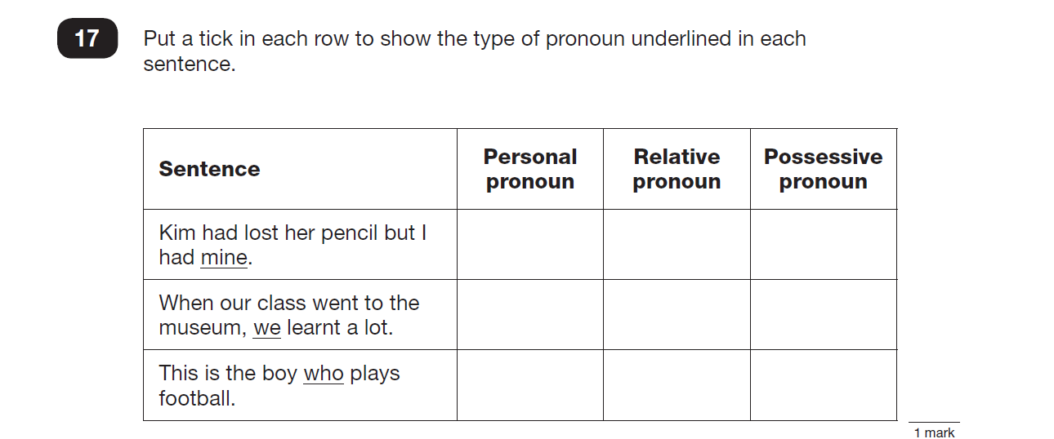
1

2
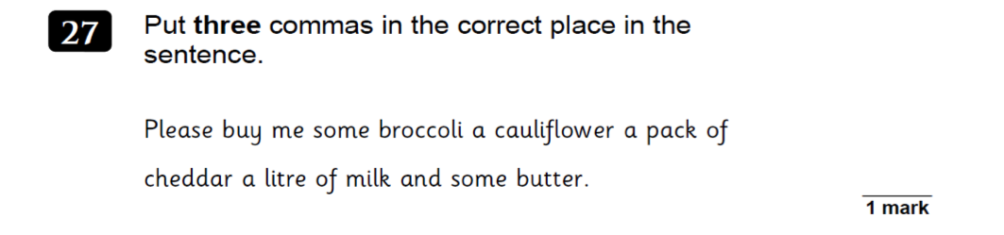

3

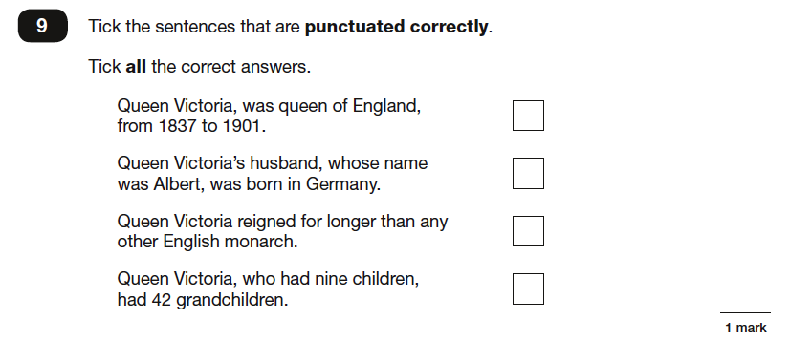
4

5
Add one suffix to both these words to make adjectives

Rest hope
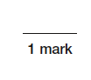
Suffix: _____________

6
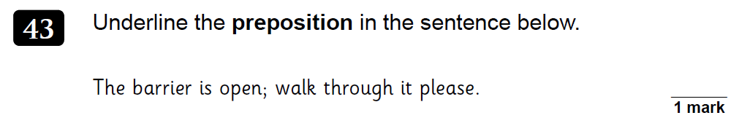

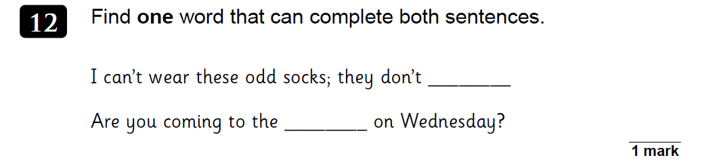
7
8
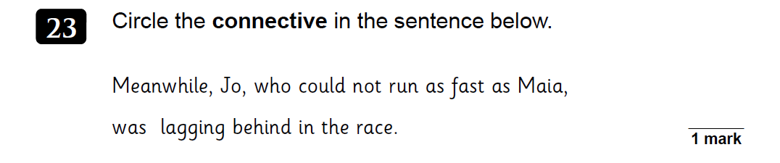
conjunction

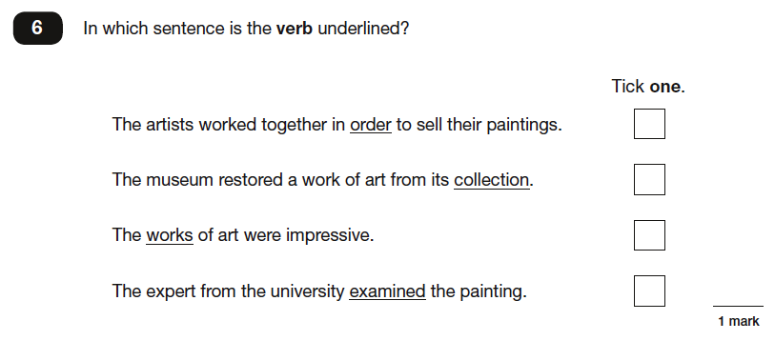
9

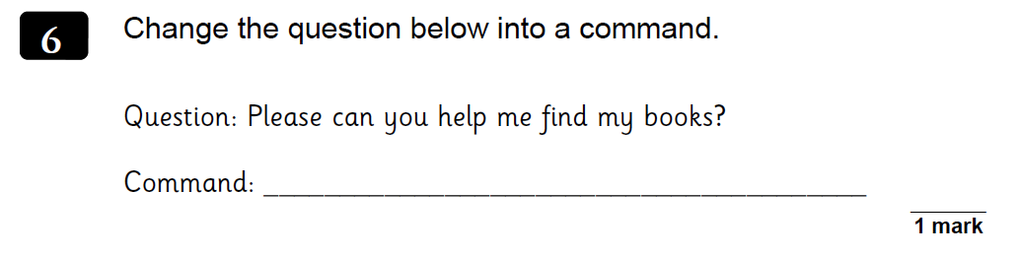
10

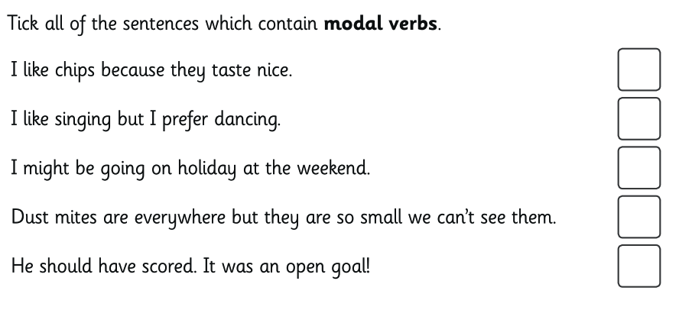
11
12
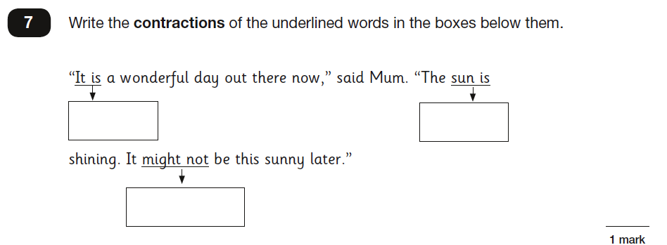

13
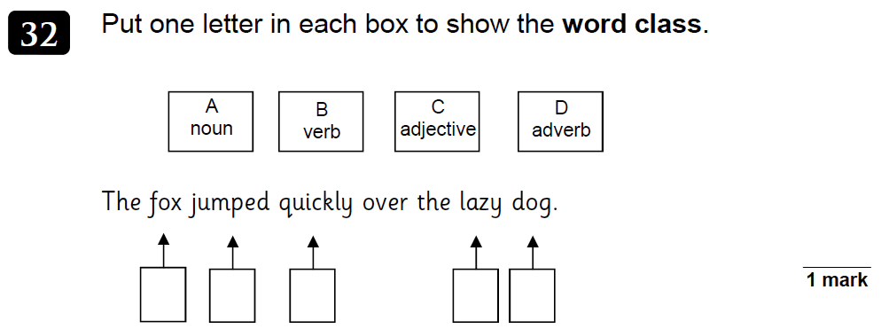

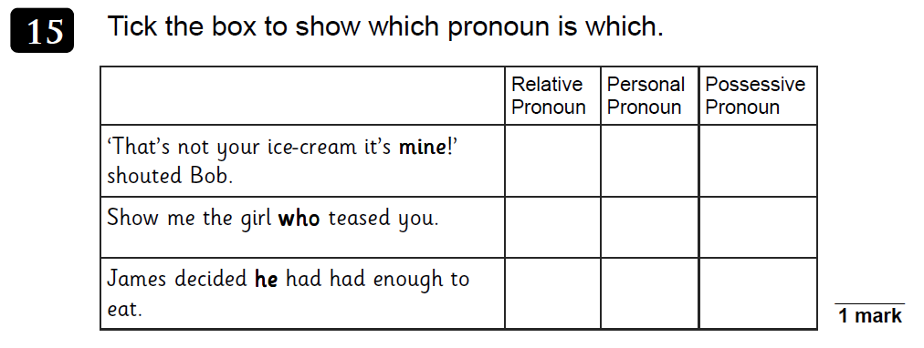
14

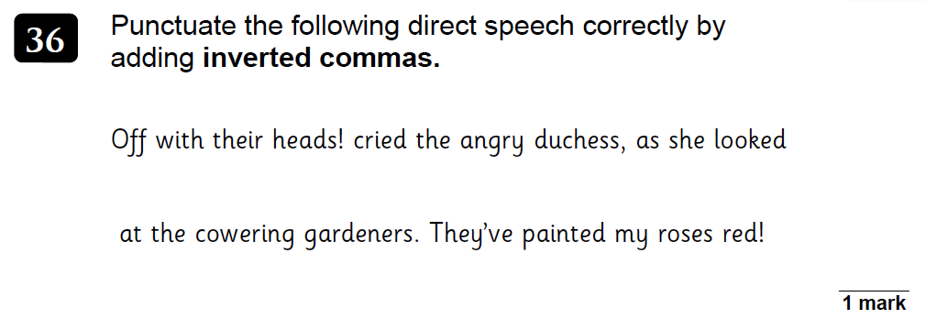
15

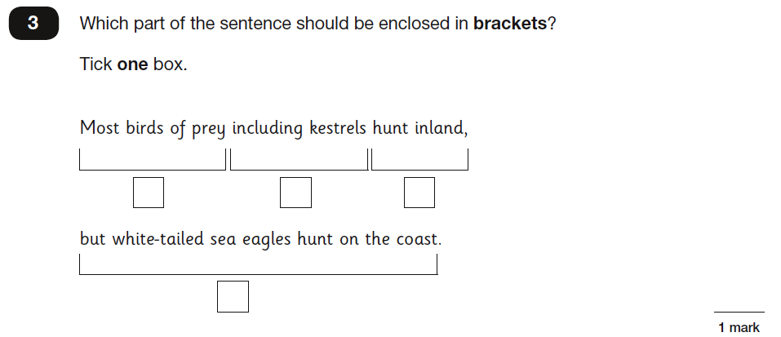
16

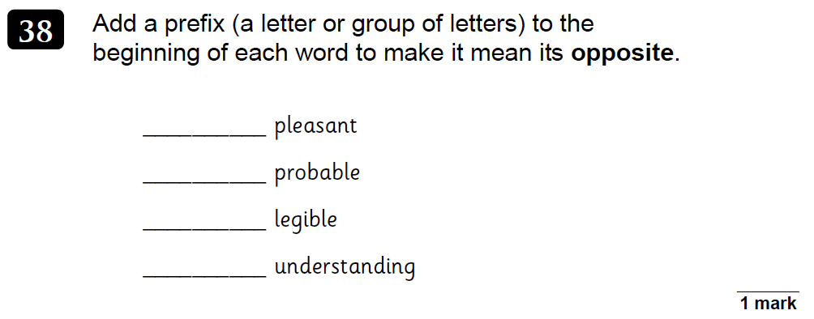
17

18
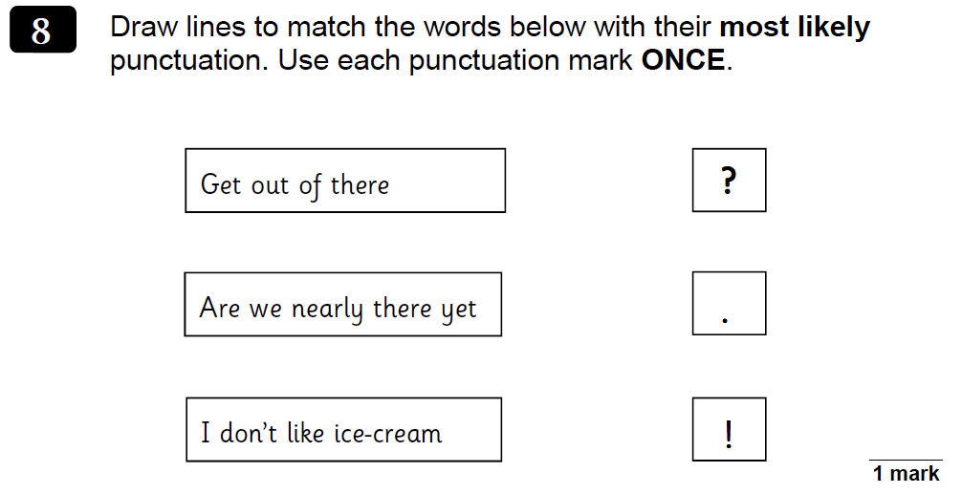

19
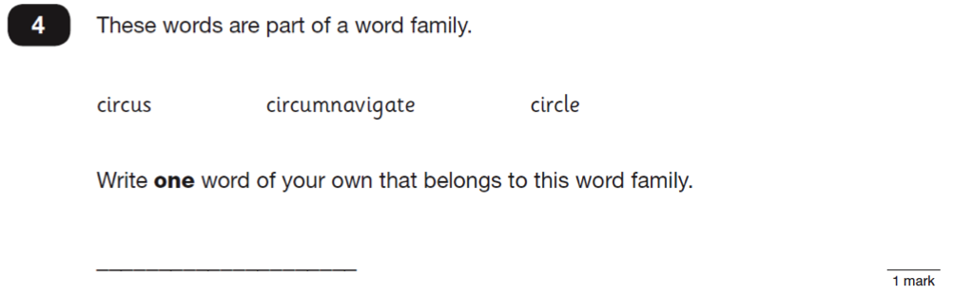

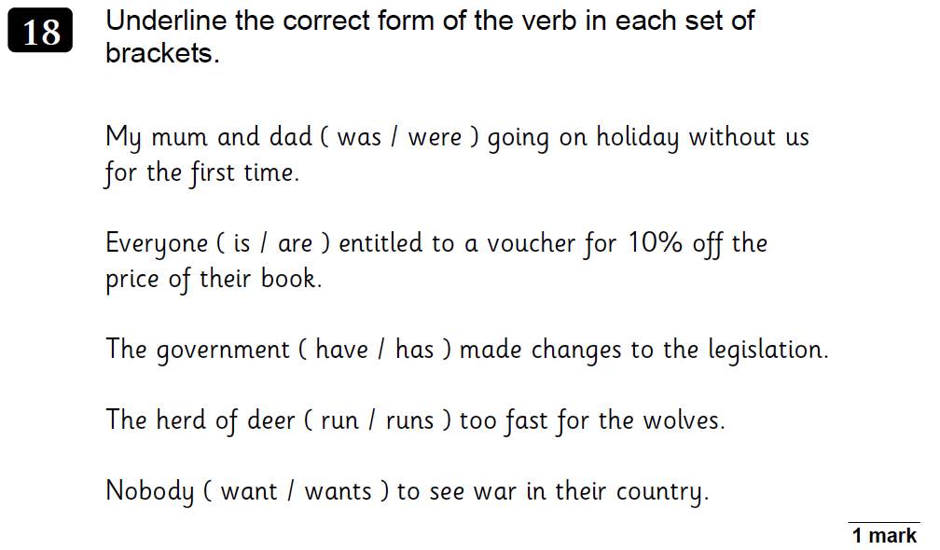
20

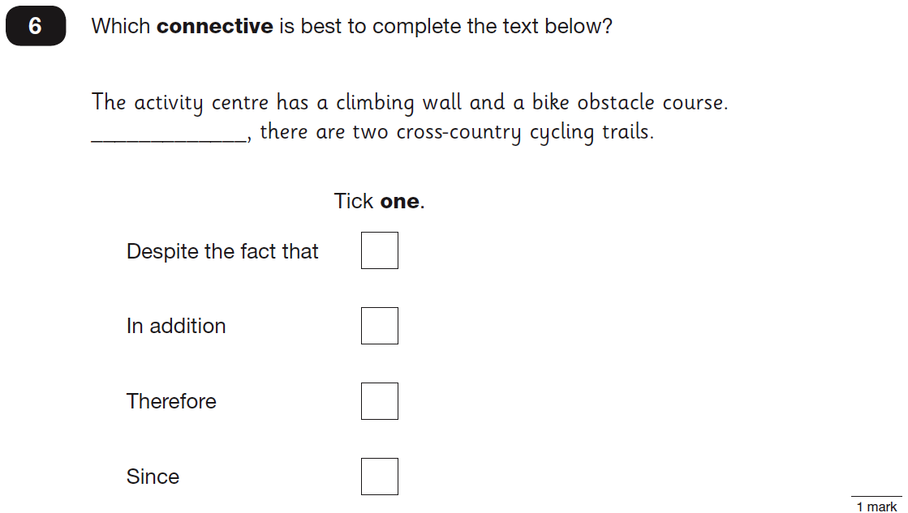
21

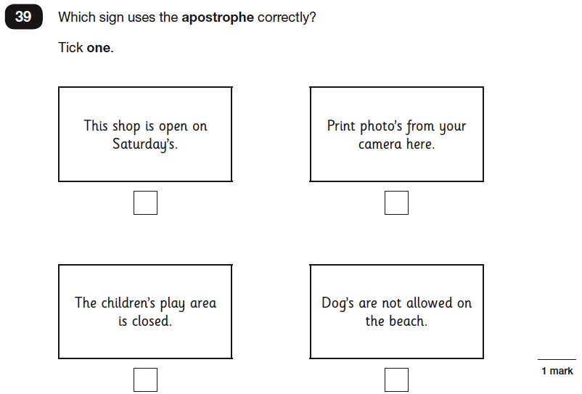
22

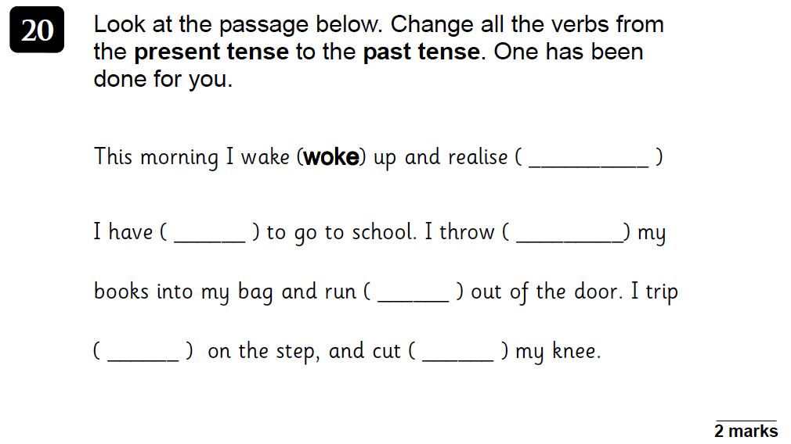
23

Add a comma to the sentence below.
24

At the end of the journey the children all thanked the bus driver.

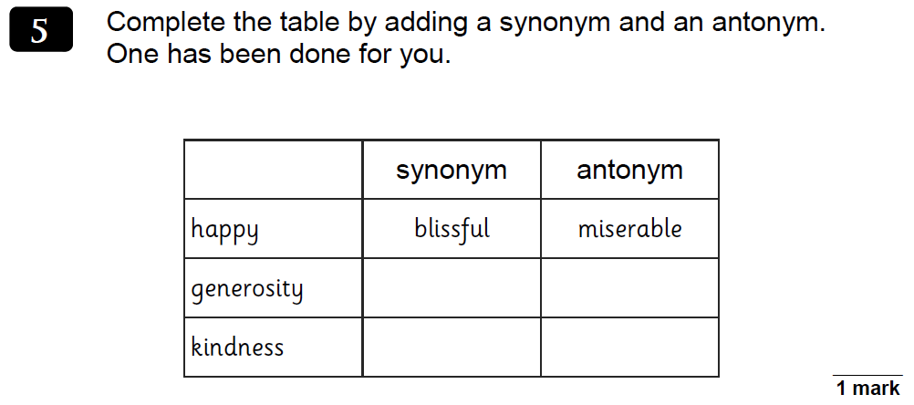
25

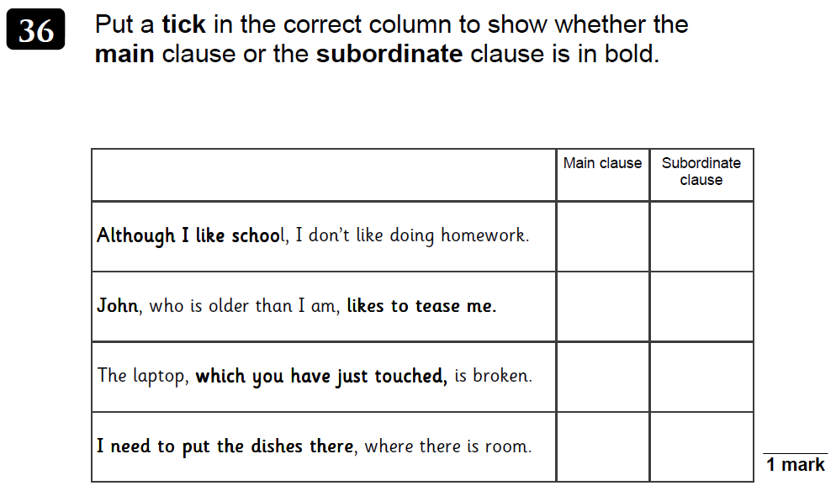
26

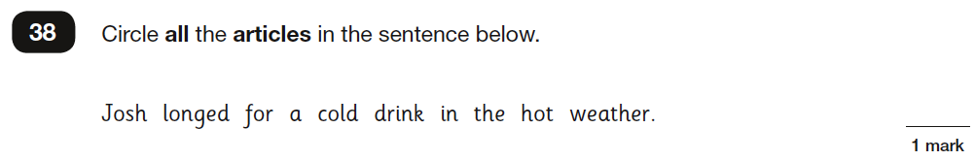
27

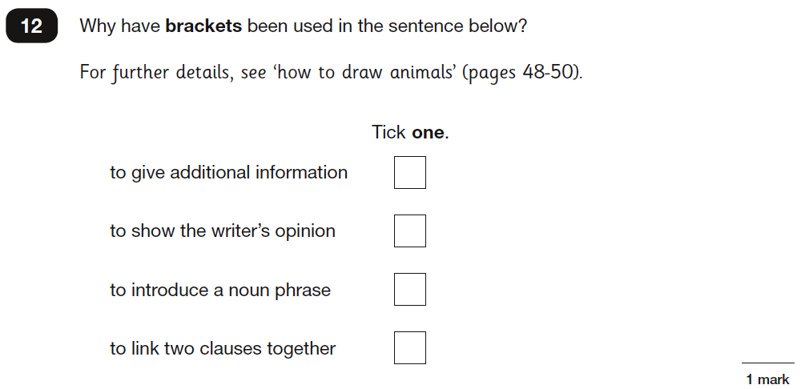
28

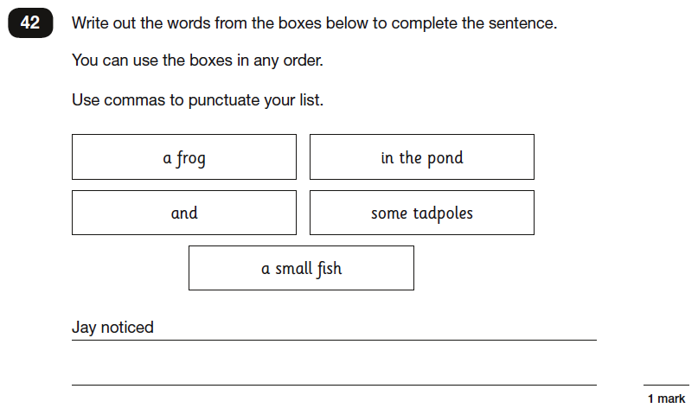
29

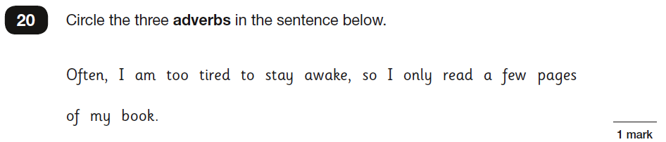
30

31
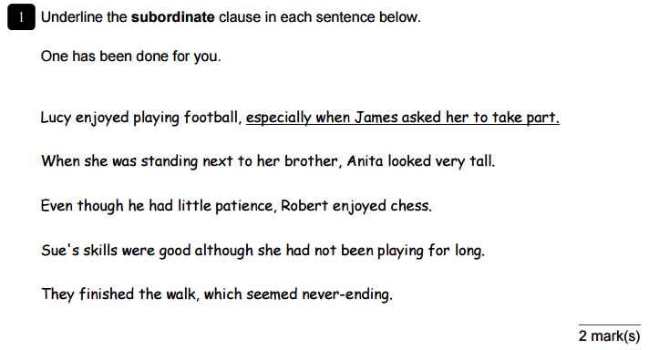

32

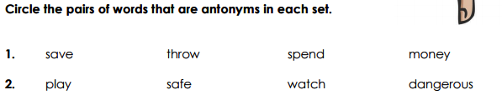

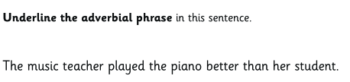
33
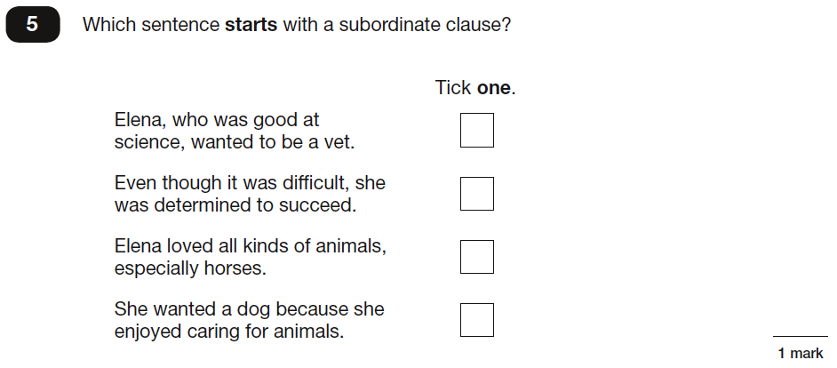
34

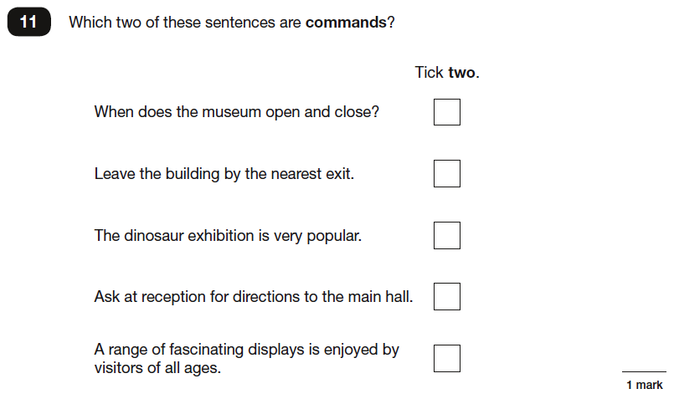
35

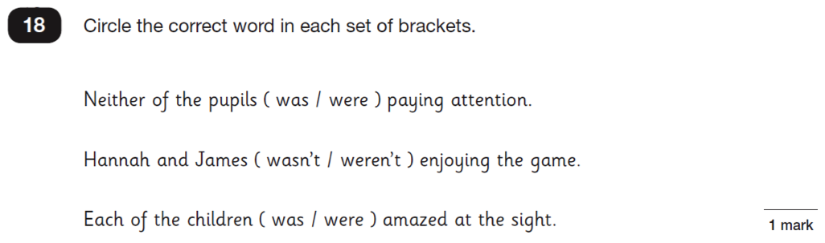
36

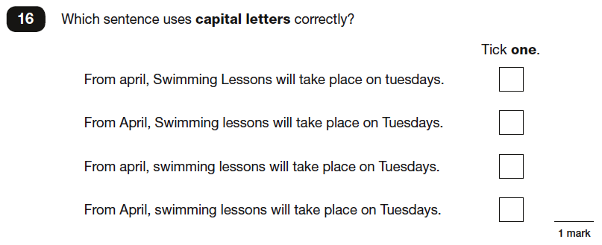
37

38
Underline the relative clause in the sentence below.

The girl that had blonde hair was late for school.

39
Insert the past progressive form of the verb in the sentence below.
( to play )
The children _______________ in the garden when it suddenly began to rain.

40
Which sentence below correctly uses the present perfect tense?

I have learned to program my computer last term.
We have been to France three times.
When I was in Scotland, I have climbed a mountain.

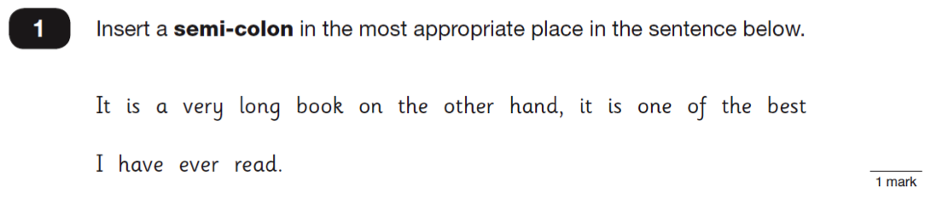
41

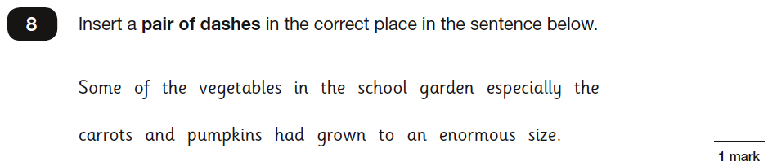
42

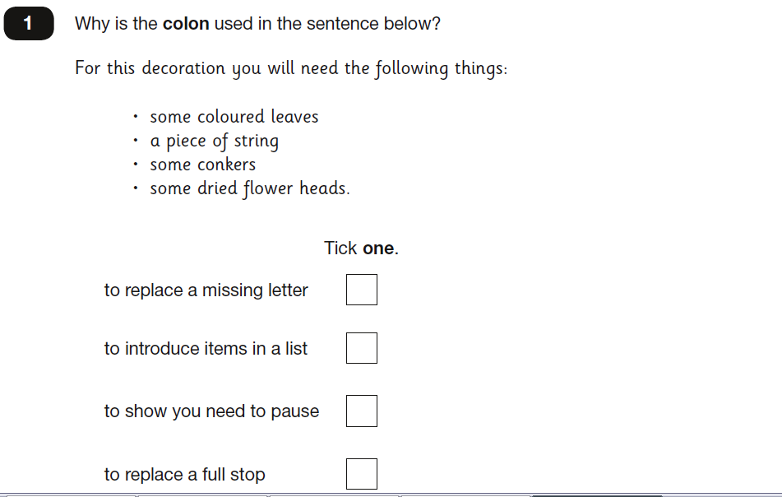
43

44
Insert the present progressive form of the verb in the sentence below.
( to play ) ( to listen)
Bella ___________ the guitar and Andrew ______________ to her.

45
Rewrite the sentence below changing the modal verb.
Remember to punctuate your answer correctly.

Sam must go to school.

______________________________________________________________

Rewrite the sentence below using the passive voice.
46
Remember to punctuate your answer correctly.

The dog fetched the bone.

______________________________________________________________

47
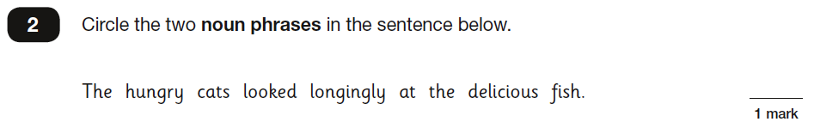

48
Which option completes the sentence below so that it uses the subjunctive mood?

I wish Sally ________ here to help us.

could be
was
were
would be

What difference does the comma make to the meaning of the sentence below?
49

“Let’s eat Grandma!”

“Let’s eat, Grandma!”
______________________________________________________________
______________________________________________________________
______________________________________________________________
End of test

