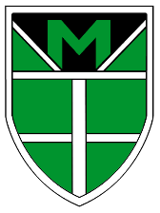
A Guide to Year 6

As you are coming to the end of Year 6, now is a good time to reflect on the learning and activities that you have been a part of.

You are going to write a guide for the present Year 5, giving them an insight into what life for a year 6 pupil is like.
Some of the things you may consider including are:
- After school/lunch time Clubs you can join.
- Roles and responsibilities you can take on – Prefect, Librarian, House Captain etc.
- Learning Expeditions (Topics) that you’ve studied.
- Things you’ve been taught across the curriculum.
- Visitors you have had in school or trips you have been on.
- Homework, spellings, reading at home, PE days etc.
- Teachers
- Any other interesting information about the year!

You may want to be creative with the layout of your guide. You could present it as a leaflet or a poster!

Remember to make it chatty, interesting and informative.
